**Donation Collection System**

**Object Oriented Analysis and Design Course Project (CS-309)**

**BS(CS) Fall 2017**

Uzair Khan

K15-2183



Supervisor: Ms. Faiza Sattar

Co-supervisor : Sir Awais

**Department of Computer Science**

**FAST-National University of Computer & Emerging Sciences, Karachi.**

**Abstract**

This project aims to implement a donation collection system. The idea is to connect willing donors with donation collectors to implement an efficient system. Donation categories such as Cash, Books, Blood, Ration and Clothes donation will be implemented.

Other features such as collection via volunteers and showing collection centers using Google Maps will be implemented. Android is the targeted platform for this application.

Introduction

As the prevalence of smartphones increases in our society, there exists a unique opportunity to take advantage of the increasing amount of user connectivity. This project hopes to improve society by connecting willing donors with donation recipients. Uncollected donations of able donors who are unsure of how to donate can be very useful to persons in need. This project aims to connect these two parties in an accessible and user-friendly manner to maximize donations collected. Ease of use and accessibility is a primary focus and will be highlighted through showing prospective donors the nearest collection centers with respect to their current location using Google Maps view. A system of riders collecting donations for key collection centers will also hopefully be established.

1. OVERVIEW
   1. Significance of the Project

The significance of this project is that it would greatly enhance the ease of donation for willing donors thereby increasing the chances that they would donate again. As this would be an application that could be downloaded by anyone, targeting the subset audience of people who would be unable or unsure to donate.

* 1. Description of the Project

The project is basically a system to collect donations of various resources from people who would otherwise be unable to donate. The issue that the project aims to resolve is that there may be a lot of potentially untapped donations in the target audience because people might not be aware of an appropriate outlet to donate their resources. This project therefore aims to bridge the gap between those with resources and those who require them. It aims to target donations of a few key resources such as clothes, rations, cash etc.

* 1. Project Category

The project is categorized as a Product based project as this is a community service project.

1. METHODOLOGY
   1. Design phase

This project will be based on the incremental software development model, specifically the Waterfall Model. This model is chosen over agile and iterative development because it is not expected that there will be any major design changes after the initial design phase. The linear model will also allow milestones such as the completion of Design, Implementation etc to serve as guidance over the project lifespan of 3 months.

* 1. Implementation phase

The implementation is proposed for the Android Mobile platform. Therefore hardware required is an Android mobile device. Database to store user information and such shall be implemented on MySQL and will be connected to our application via web.

* 1. Testing phase

The application will be tested to a very limited extent during the implementation phase. Once the project has reached full fidelity and has been implemented, then heavy testing of the project will commence. The aim would be to find bugs or instability in both the back end of the project(the database) and the front end (the mobile application).

* 1. Evaluation phase

Given the nature of the project as being product based, the application would be evaluated through software demonstrations as well as benchmarking of the application to be within reasonable performance.

1. FEATURES

Convenience:

The primary focus of the app. Convenience will be prioritized by making both receiving and giving donations easier through various features.

Different kinds of Donations:

The types of donations being targeted in this application are Rations, Clothes, Books, Cash and Blood donations. Further subcategories of donations such as emergency donations are also included.

Personal/Emergency cases:

If a user is in need of donations, he can submit a request. If his request and case is verified by trusted sources, then his personal donation can be broadcasted to other users.

Google Maps:

Google Maps will be utilized to show you the nearest collection centers.

Payment Subsystem:

A subsystem for processing transactions will be implemented for cash donations.

Rider collections:

Riders will be employed from collection agencies to further simplify donations if required.

1. SYSTEM ARCHITECTURE

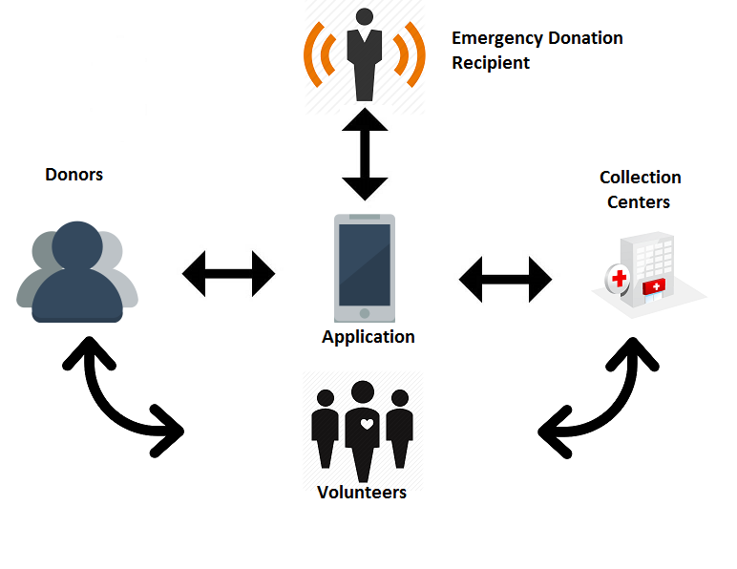

Potential donors use the app to find a collection service or fulfill a donation request. Collection agencies are shown to the donors, and riders are dispatched if necessary for donation collection.

1. PROJECT FEASIBILITY

You should provide complete details of your analysis about your proposed project feasibility based on the following factors.

• Technical Feasibility

The project is easily possible with the current technology. The technical risk is minimal as all the platforms being used are well established and stable.

• Economic Feasibility

The project is economically feasible as there are no major development and operational costs. The resource constraints will definitely be enough.

• Schedule Feasibility

Time constraints for the project is of 3 months. Further details are in the project timeline below.

1. HARDWARE AND SOFTWARE REQUIREMENTS

Hardware requirements for the application is firstly an Android device capable of running the application. That ties into the software requirement of Android Studio as well. Furthermore since MySQL will be used as the database, a web service to connect the Android application with the database will require PHP as well. A machine capable of acting as a server for the database will also be required.

1. PROJECT TIMELINE

|  |  |
| --- | --- |
| Weeks | Schedule |
| Week 1 | Research Work |
| Week 2 | Analyzing the problems |
| Week 3 | Creating Work frame |
| Week 4 | System Architecture |
| Week 5 - 10 | Implementation Phase |
| Week 11 | Testing Phase |
| Week 12 | Finalizing the project |

1. PROJECT DELIVERABLES

* Android Application
* UML Design
* Code
* Documentation
* Final Report